|  |  |
| --- | --- |
| MIS782 – Value of information  Assessment 2 – Prepare a business case | Abstract  Proposing an opportunity to Nettavisen for IT investment |

Group 71:

|  |
| --- |
| Rajeshkumar Mourya |
| Jay Trivedi |
| Neeraj Raghav |
| Shubham Srivastava |

# Executive summary:

We are proposing an opportunity to Nettavisen for investment in IT and creating additional revenue streams and sorting existing issues with data practice. We analysed recent mobile services industry in Norway and capabilities of social media competitors such as Google, Facebook and our findings suggest there is a rise in revenue generated by mobile applications and the market is to be captured. Nettavisen being a leading online publisher in Norway, the solution we are proposing will attract larger consumer base over time. The solution is completely data driven and primarily based on mobile traffic data, locations etc. We are recommending Nettavisen to implement the solution considering either outsourcing or building in-house IT team that will support the solution.

# Business opportunity:

The firm had in excess of 5 million unique visitors to its website in the first week of November 2014 (Maeland, 2014), out of the 5 million, around 2.2 million came via mobile devices. Considering the big customer base using mobile devices for browsing Nettavisen’s digital media, this customer base can be used to provide personalised content which can result in better user experience and engagement and thus provide additional streams to generate revenue through usage of the mobile app data and location of the users to provide better user experience and content advertising.

The chart below shows the increase in revenue from mobile services in Norway as compared broadband or telephony and the stats for mobile services revenue are clearing ahead of other services.

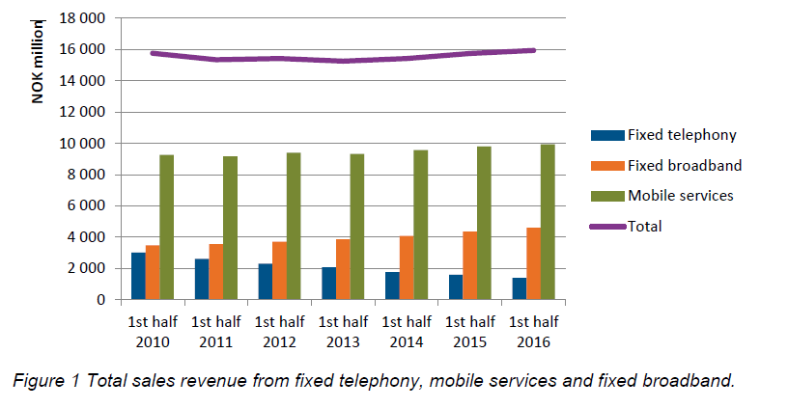

(Norwegian communications authority, 2016).

Considering the traffic received via mobile data and the increase in revenue generated from the mobile services in Norway are on the rise, we believe our solution will generate profits for the organization.

# Revenue generation:

* As mentioned earlier, 2.2 Million unique visitors were from mobile devices in Nov 2014 for Nettavisen’s website, assuming that out of these 100K users start using Nettavisen’s mobile application its launch:
  + We are generating revenue through following:
    - Use location-based data and provide brand advertising accordingly
    - Use mobile traffic data to analyse user behaviour pattern and provide personalised content and advertising
    - Referral marketing: Advertising third party applications

We are charging CPC (cost per click) for an advertisement at 0.3$ (Pratskevich, 2018) and assuming we receive around 1 Million clicks for these ads in a year, we will be making 300K $ per annum based on our solution.

# Business and IT Alignment:

Nettavisen is providing a purely online operation in Norway and to further enhance this, building a mobile applicable is next steps towards it which aligns with the aim to develop products, exploring new markets. Nettavisen is trying to realise big data analytics to expand boundaries of online exploration. According to RBV of Nettavisen, Nettavisen has young and diverse workforce of 76 employees, ageing in thirties on average, most of them are with online experience and approximately 50% of the employees have some experience from printed media (Zaki, Boe-Lillegraven & Neely 2016, p. 8) while VRIO suggests lack of data practices resulting in complications to understand user needs and behaviour and it lacks capabilities to link audience preference to real time advertising (Zaki, Boe-Lillegraven & Neely 2016, p. 10) while social media players such as Facebook have real time data processing capacity (Chen et. El, 2016) which may prove vital for Nettavisen to hold the competitive advantage they currently have. One of the external issues identified with financial resources was For Nettavisen to generate revenue and stay competent in Norwegian market, a distinct quality product is required which should support cost effectiveness of firm, diverse revenue streams and focus on niche audience. Our solution is helping Nettavisen to generate new revenue stream and a focused approach for audience using the solution through data analytics.

Currently Nettavisen does not have technical capabilities and resources to develop a mobile application which may affect the implementation cost of our solution as the organization either have to outsource the development or onboard an In-house team which can develop the application and support it. Either of the alternatives are Strategic IT investments for Nettavisen given that current human resource and organizational capabilities will be unable to implement the solution and the investment will have short term and long-term benefits and risks associated which will be discussed in detail further in this business case.

Alternatives to implement the solution:  
1. Outsourcing the application development and support:

One of the alternatives for implementing the solution is to outsource the development and support of the product (mobile application). Outsourcing is not a black sheep in market even the biggest market players are doing it and getting benefits of the experience and resources these outsourced firms hold.

## 2. In house team for IT and development:

Other alternative is to create an in-house IT team which will manage development of the product and support it. This will help the organization to increase the technical capabilities. This may play a vital role given competitors such as Google and Facebook have in-house development teams as well as outsourcing capacity.

## 3. Status quo (Optional)

Status quo or doing nothing and going with current DDBM of having website based online publication which eliminate costs and risks involved with alternatives mentioned above but this decision may prove critical for firm in order to capture new market and compete against social media players in Norwegian market such as Facebook and Google who are trying to capture most of searches and advertising in European market.

# Analysis of Alternatives:

1. **Outsourcing**

Outsourcing the application is a viable option for Nettavisen as it offers various benefits. Implementation of DDBM architecture requires a complex system integrations and collaborations between various data source, upstream & downstream. In order to make this Module as a whole efficient a constant sync between all the systems is mandatory. Outsourcing makes this challenging task relatively easy as the whole IT division can be moved to the service providing companies. These service-based companies are well specialized in handling the enterprise IT requirements and resources for successfully running the business. (Bera, 2017)

**Feasibility**

* DDBM Architecture requires incorporation of big data technologies for data reporting and prediction. Outsourcing firms like Accenture, Capgemini etc. have capability to handle enterprise level business and its needs. Therefore, Nettavisen can easily invest in these service-based companies which can take the ownership of the company IT’s division.
* The handover of technical documentation for application support is relatively easy which can be done remotely as well thus Outsourcing IT field of the company is feasible. Nettavisen can document their current data handling process for their DDBM architecture and can easily plan to transition the application process,
* Having diverse in-house capabilities is a would be a challenge for Nettavisen thus by Outsourcing technology & research to companies that specializes in data driven projects, decision makers are more likely to have high quality & usable results.

**Benefits**

* Outsourcing brings many benefits to the company. As the outsourcing firm would contain resources from different background, experience & companies which can provide them an extra edge over in-house development. Nettavisen can leverage the use of skilful resource in outsourcing companies to improve its existing process to make their model more reliable and efficient.
* Nettavisen can reduce its operational cost by outsourcing the work. The countries where these IT works are usually outsourced has a higher $ to local currency conversion value. The saved revenue by the company can be further reinvested in R&D of the company.
* Nettavisen can also reduce Labour cost as hiring and training an IT staff can be very expensive, and temporary employees don't always live up to your expectations. Outsourcing lets you focus your human resources where you need them most.
* Nettavisen can also work on implementing newer technologies as a quality outsourced IT service organization will have the assets to begin new tasks immediately. Taking care of a similar undertaking in-house may include weeks or months to contract the correct individuals, train them, and give the help they need. For most implementations, quality IT organizations will get long stretches of experience the starting sparing time and cash.
* Nettavisen can be benefited as these outsources companies have highly skilled employees which can improve the current DDBM architecture & Big Data technologies with current advancements in IT field like machine learning, artificial intelligence to make the process of data projection and customer data interpretation more fast, reliable and accurate.
* Nettavisen can also leverage benefits of time zone if the process is outsourced to countries in a different time one. This will help to improve the company’s productivity as the work will be done round the clock. Ex- A pending task in Nettavisen can be picked up by the outsourced company and worked upon.
* A hidden benefit of outsourcing is that if Nettavisen by any chance faces problems due to natural calamities, technical crisis or market fluctuations. Then the offshore outsource partners can still keep working on their assignments. This especially beneficial in bringing back the company back on track. This is usually termed as Business continuity programs. (Smith, 2012)

**Cost**

* Nettavisen decision on outsourcing its IT to service-based firms located in countries like India, Philippines etc can save them almost 60% of their operating cost in comparison to inhouse operation.
* There are many other benefits as Nettavisen doesn’t have to pay overhead cost such as superannuation, payroll tax & holiday pay as these things will be managed under the outsourced service-based company under fixed budget of Nettavisen.
* Nettavisen can also save up to 50% of its training & recruiting cost as the majority of the work would be handled by outsourced employees and it would be responsibilities of the service-based companies to acquire a competent staff for the job role.
* Below are the rates for app development (Think Mobiles, n.d.)

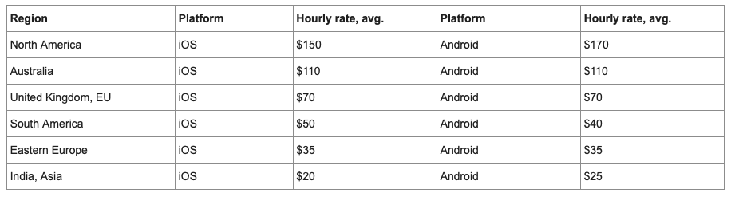

* The figure indicates if the mobile application is outsourced, it would take an estimate of $40k ~ $50k. the above figure also indicates that it would roughly take $15k per annum to maintain & support the application
* Likewise, the hourly rates for central and East Asia are relatively low as compared to rest of the world. (Qubit Labs, n.d.)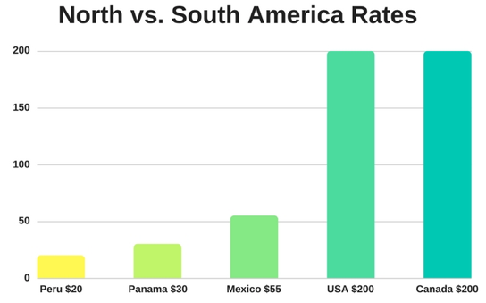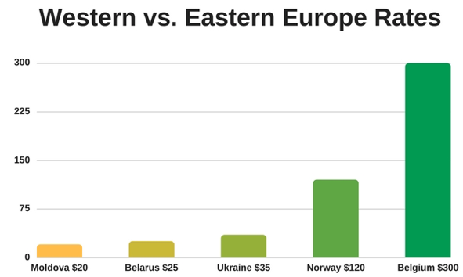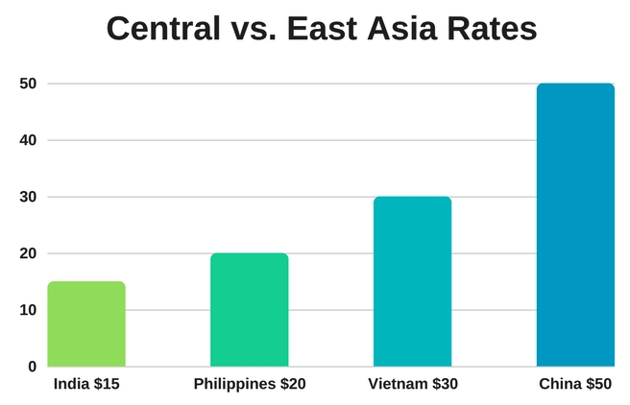
* It can be estimated that an annual salary of $75k ~ $85k for employees and a maintenance cost of $15k would be required to run the IT infrastructure if the work is outsourced.
* The profit margin of Nettavisen would drastically increase if the IT infrastructure and application support is outsourced thus making an exponential increase in company’s revenue.

**Cost Benefit Analysis:**

|  |  |
| --- | --- |
| Costs (Per annum) |  |
| Establishment | N/A |
| System maintenance and support | 15,000 |
| Cost of App development | 85,000 |
| Training and Education | N/A |
| Value Management Hours spent | N/A |
| Total | 100,000 |

|  |  |
| --- | --- |
| Revenue (Per annum) |  |
| CPC (advertisements) income | 300,000 |
| Total | 3,00,000 |
|  |  |

Net Cost of running the application: 3,00,000 - 100000 = 200,000 in profits post deployment

**Risks**

* Outsourcing the Nettavisen IT division also poses few risk and threats as there can be a possibility of weak management. Weaker management can be infective in maintaining the SLA of Nettavisen which may lead to production issues and data discrepancy in the company. Breach in SLA can also incur huge cost as it may be impacting the end users & customers of Nettavisen
* Nettavisen may have a chance of security breach and compliance issues if appropriate security measures are not in place between Nettavisen and outsourced companies. (Zuniga, 2009)
* Nettavisen must have a mandatory Non-Disclosure agreement with the outsourced company as the data involved in profiling an individual is highly sensitive and any breach in its security can cost Nettavisen a huge lawsuit.
* There is also a possibility that the outsourced company may not have adequate laws protecting intellectual property or the private data in their country, therefore Nettavisen may find it difficult to prosecute if there is any incident of an illegal activity.

1. **In House IT Team**

As compared to Outsourcing a certain activity, in house maintenance means that hiring professionals and setting up a whole department just for that particular tasks to be performed. IN outsourcing, your hire a third-party company or professional to do the task for you. Outsourcing decisions are mainly based on a single motivating factor i.e. cost but a company should consider a lot of different things while taking a decision to outsource a process or not.

**Benefits of in-house IT maintenance team** –

**Less Risk of Obsolesce** – In rapidly changing IT environment, a technology becoming obsolete is not a big issue but if you have outsourced certain IT process, it can cost you a lot if the outsourcing partner is less dynamic. Whereas if you establish in house solution there are high chances that you will be able to educate or train them on any new technology making them more dynamic.

**Control Distribution** – While doing any process with the in-house team there are very less chances of it making the control dilution inside the company. On the other hand, if you outsource the process, it may require you to provide the outsourced partner with additional authority to perform certain tasks required for the process to be executed. (Buck-Lew, 1992)

**Employee morale** ­– When you outsourced a certain task it may result in making your own employees feel unsecured about their jobs. They also fear that they may be asked to work for a vendor and they might think that the management believes outsiders are more competent than them to perform the task. On the other hand, if you choose in house solution for any of the processes it boosts the morale of employees making them feel more secured and faithful towards their employer. (Belcourt, 2006)

**Financials** – Cost of having own IT maintenance team is one the biggest factor while considering outsourcing a process. Establishing a whole new team inside the organisation to perform a certain process can result in very high establishment costs. While hiring a vendor to perform a task can prove to be cost efficient as they provide the same service to different clients. (Belcourt, 2006)

The outsourcing partner takes advantage of economies of scale on the hardware and professionals making them more cost efficient. (Teng, 1993)

**Less Expertise** - While we outsource a certain task, the vendor is already performing the same task for different companies. The vendor can be considered as experts in their field and they have more knowledge in dealing with situations that may arise while performing the tasks. Where as in house IT team may be new to the type of difficulties they might face in the process. Also, hiring an Expert just to perform a single process is itself a costly matter, which can easily be achieved by outsourcing the project itself.

**Improved Quality of the service** – As a contract is signed between the vendor and the company outsourcing a process. The parameters on which the quality will be measured (Quality Standards) can be written more precisely and the company can expect the quality of the services to be of the optimum level.

**Strategic Focus** – A company should know that achieving excellence in every area they practice is very difficult and they might have resource or technology limitations as well. They may be very good at the work they do but they might not be able to perform all the task in a very effective way. So, by outsourcing they can focus on their main strategic idea and leave the process to the outsourced vendor and focus on the main work. (Belcourt, 2006)

**Conclusion**

While choosing between Outsourcing or in-house solution for any process, there are many different things to be taken into consideration like the control, cost of establishment, expertise and the time limitation. All these things can play a significant role in taking the decision and can impact the plan. It depends on company’s financial and strategic situation to decide whether they should or they should not consider outsourcing as an option or not.

**Cost Benefit Analysis**

**Cost of setting up the In-house Team**

|  |  |
| --- | --- |
| Costs (Per annum) |  |
| Establishment | 75,000 |
| System maintenance and support | 50,000 |
| Salary of Employee | 200,000 |
| Training and Education | 50,000 |
| Value Management Hours spent | 20,000 |
| Total | 395,000 |

|  |  |
| --- | --- |
| Revenue (Per annum) |  |
| CPC (advertisements) income | 300,000 |
| Total | 3,00,000 |
|  |  |

Net Cost of running the application – 3,95,000 – 3,00,000 = 95,000 in loss post deployment

The overall cost for choosing in house team as a mode of solution is 95,000 per annum, which is the difference between its annual on-going cost and the revenue it will help in generating from Nettavisen’s application visitors.

# RECOMMENDATION

As the Nettavisen company contributes of around 76 people, outsourcing would be of a great benefit because all the focus and the energy of the employees/personnel would be completely on accomplishing the job/task assigned to them. As a result, the risk of occurring the errors would be at minimal. At the time of a major mishap or issue occurred in a specific area or division, a specialist of that skill set would be get appointed to tackle the issue. Hence the company would get a more specialized expertise and would result to a positive outcome of that task. However, one more plus point of outsourcing is that this approach would result to cost effectiveness, less time consuming and would also result to a better performance of the company. It will also lead to lower risks and more control over the task. By hiring a specialized skilled set personnel for the task, it also increases the risk of losing sensitive data and leakage of confidentiality of the company. Although this approach is cost-effective but there are many hidden costs prevailing in between. Degradation in quality of work can be experienced if the outsource personnel is not that trained for the task or is inexperienced. This would be a short term strategic investment plan for the Nettavisen.

A huge amount of investment is required for hiring your own team. There will be a reduction in the strategic flexibility of the company as all the focus is divided towards various evolving sectors. There would be an increase in the administration burden as the team expands and tasks gets assigned to each individual. Due to increase in burden there would be an increase in the performance pressure of the employees and that would result to degradation in the team work and the quality of work assigned. As the team is working in house they won’t get an opportunity to expand their ideas or business by getting to know other personnel of various other employees and that would lead to lack of networking. As Nettavisen consists only a handful number of employees the cost spent on each employee would be less. As the employees in the inhouse approach work in their own office environments that would also lead to less travel cost. During various training sessions or seminars, it focuses mainly on a group of employees/personnel which would increase in grasping power of the information provided in it.

From the above stated pros and cons for the outsourcing and in-house approach, the outsource approach would be beneficial for a short-term strategic plan for the company as compared to a long term approach. Although at first the in-house approach would sound a bit non convincing but for a long-term approach of a time span of around 5-10 years this approach would provide a greater benefit to the company.

# IMPLEMENTATION PLAN

The high-level implementation plan for outsourcing is shown in the figure.

|  |  |  |  |  |  |  |  |  |  |  |  |  |  |  |  |  |  |
| --- | --- | --- | --- | --- | --- | --- | --- | --- | --- | --- | --- | --- | --- | --- | --- | --- | --- |
|  | Jun-19 | Jul-19 | Aug-19 | Sept-19 | Oct-19 | Nov-19 | Dec-19 | Jan-20 | Feb-20 | Mar-20 | Apr-20 | May-20 | Jun-20 | Jul-20 | Aug-20 | Sept-20 | Oct-20 |
| Evaluation | x | x |  |  |  |  |  |  |  |  |  |  |  |  |  |  |  |
| Vendor Search |  |  | x | x | x |  |  |  |  |  |  |  |  |  |  |  |  |
| Contract/Agreements |  |  |  |  |  | x |  |  |  |  |  |  |  |  |  |  |  |
| Scope Definition |  |  |  |  |  |  | X |  |  |  |  |  |  |  |  |  |  |
| Product Development |  |  |  |  |  |  |  | x | X | x | x | x | x |  |  |  |  |
| Soft Launch |  |  |  |  |  |  |  |  |  |  |  |  |  | x |  |  |  |
| Testing |  |  |  |  |  |  |  |  |  |  |  |  |  |  | X | x |  |
| Rollout |  |  |  |  |  |  |  |  |  |  |  |  |  |  |  |  | x |

1. Evaluation

In this process, first the data is gathered from various sources. Once the process of data gathering is completed the product is evaluated based on safety and sustainability for use by the customers.

1. Vendor Search and contracts/Agreements:

Nettavisen will be searching for vendors for the development, where options being looked are either of Accenture, Cognizant, Infosys etc. who are reputed and possess high capacity to deliver the desired results.

Contracts, apart from formal paperwork, will also involve GDPR (General Data Protection Regulation) policies implemented recently in Europe and hold high importance.

1. Scope Definition

Once we have the vendor the process of scope definition is done in which the various features, functions and designs are to be discussed and designed to make the product steadfast in the market for competition.

1. Product Development

In this section, product development is done by keeping in mind the evolving demand of the products and its quality by the user/customers. The gathered data is more filtered to produce the desired or refined product.

1. Soft Launch

In this process a beta version of the product is released for the customers for debugging the errors and to get a feedback from the users before the actual product launch

1. Testing

The testing process is done in order to look out the flaws or loopholes that are made during the development process. It gives a point of satisfaction to the customers and gives a sense of reliability towards the organization. The software quality is polished to meet up to the expectations of the customers. It strengthens the bond between the customers and the company.

1. Rollout

After going through all the stages at last the refined product is been put out for the customers to try and use it.

# Bibliography

* Bera, S. P. (2017). *The concept of outsourcing.* IOSR Journal of Computer Engineering (IOSR-JCE) e-ISSN: 2278-0661,p-ISSN: 2278-8727, Volume 19, Issue 4, Ver. IV. (Jul.-Aug. 2017), PP 37-39.
* *Qubit Labs*. (n.d.). Retrieved from qubit-lbs.com: https://qubit-labs.com/average-hourly-rates-offshore-development-services-software-development-costs-guide/
* Smith, A. (2012). *The Pros and Cons of Outsourcing.* University of Nevada, Las Vegas.
* *Think Mobiles*. (n.d.). Retrieved from ThinkMobiles.com: https://thinkmobiles.com/blog/how-much-cost-outsource-app-development/
* Zuniga, L. J. (2009). *Drivers of the Offshore Outsourcing of R&D: Empirical Evidence from French Manufacturers.*
* Zaki, M, Bøe-Lillegraven, T and Neely, A 2016, *A Transition Towards a Data-Driven Business Model (DDBM): A Case Study of Nettavisen Online Newspaper Publishing*, doi: <http://dx.doi.org/10.4135/9781473970113>
* Mæland, K 2014, *Milepæl for Nettavisen*, Nettavisen, retrieved 1 April 2019, <https://www.nettavisen.no/nyheter/milepael-for-nettavisen/8496900.html>
* Pratskevich, A 2018, Google Display Ads CPM, CPC, & CTR Benchmarks in Q1 2018, retrieved 10May 2019, <<https://blog.adstage.io/google-display-ads-cpm-cpc-ctr-benchmarks-in-q1-2018>)>
* Chen, GJ, Wiener, JL, Iyer, S, Jaiswal, A, Lei, R, Simha, N, Wang, W, Wilfong, K, Williamson, T and Yilmaz, S 2016, Realtime data processing at Facebook. In *Proceedings of the 2016 International Conference on Management of Data* (pp. 1087-1098). ACM.
* Belcourt, M. (2006). The benefits and the risks. *Human resource management review 16(2)*, 269-279.
* Buck-Lew, M. (1992). To outsource or not? *. International Journal of Information Management,* , 3-20.
* Teng, V. G. (1993). The decision to outsource information systems functions. *Journal of Systems Management.*, 34+.

Effort Distribution form:



